The term "IM process topics" most logically refers to the Incident Management (IM) process as defined by ITIL 4, but the practical implementation and terminology you see in forms and menus are specific to ServiceNow.
Here is a breakdown of the two contexts:

1. The ITIL 4 Context (The "Why" and the "What")
ITIL 4 (Information Technology Infrastructure Library) defines Incident Management as a core IT practice. In ITIL, the "IM process topics" cover the theoretical and best-practice stages of handling an incident:
- Process Purpose: To minimize the negative impact of incidents by restoring normal service operation as quickly as possible.
- Key Topics:
  - Incident Identification and Logging
  - Prioritization (Impact x Urgency)
  - Investigation and Diagnosis
  - Resolution and Recovery
  - Closure
In this context, IM Process Topics are the steps and principles that guide an organization's approach to fixing things that are broken.

2. The ServiceNow Context (The "How" and the "Where")
ServiceNow is the platform where those ITIL principles are put into practice. The "IM process topics" in a ServiceNow context refer to the configuration and components used to manage the incident lifecycle, such as:
- The Incident Table (incident): The record itself, where all data is stored.
- Incident State: The progression through states like New, In Progress, On Hold, Resolved, and Closed (which we just discussed!). These states define the process flow.
- Workflows/Flow Designer: The automated logic that moves the incident through its lifecycle, escalating it or triggering notifications based on the state.
- SLAs: The service agreements that track the clock against the process steps.
- Incident Forms and Views: The visual interface that allows agents to perform the steps defined by the ITIL process.
The Answer
When discussing the stages and definitions of handling a broken service, the reference is to the ITIL 4 Incident Management Process.
When discussing fields, tables, states, or automated movement within the system, the reference is to the ServiceNow platform implementation of that ITIL process.
Which of those two areas—the theoretical process steps of ITIL, or the specific technical components within ServiceNow—is most relevant to your current work?

https://developer.servicenow.com/app.do#!/home
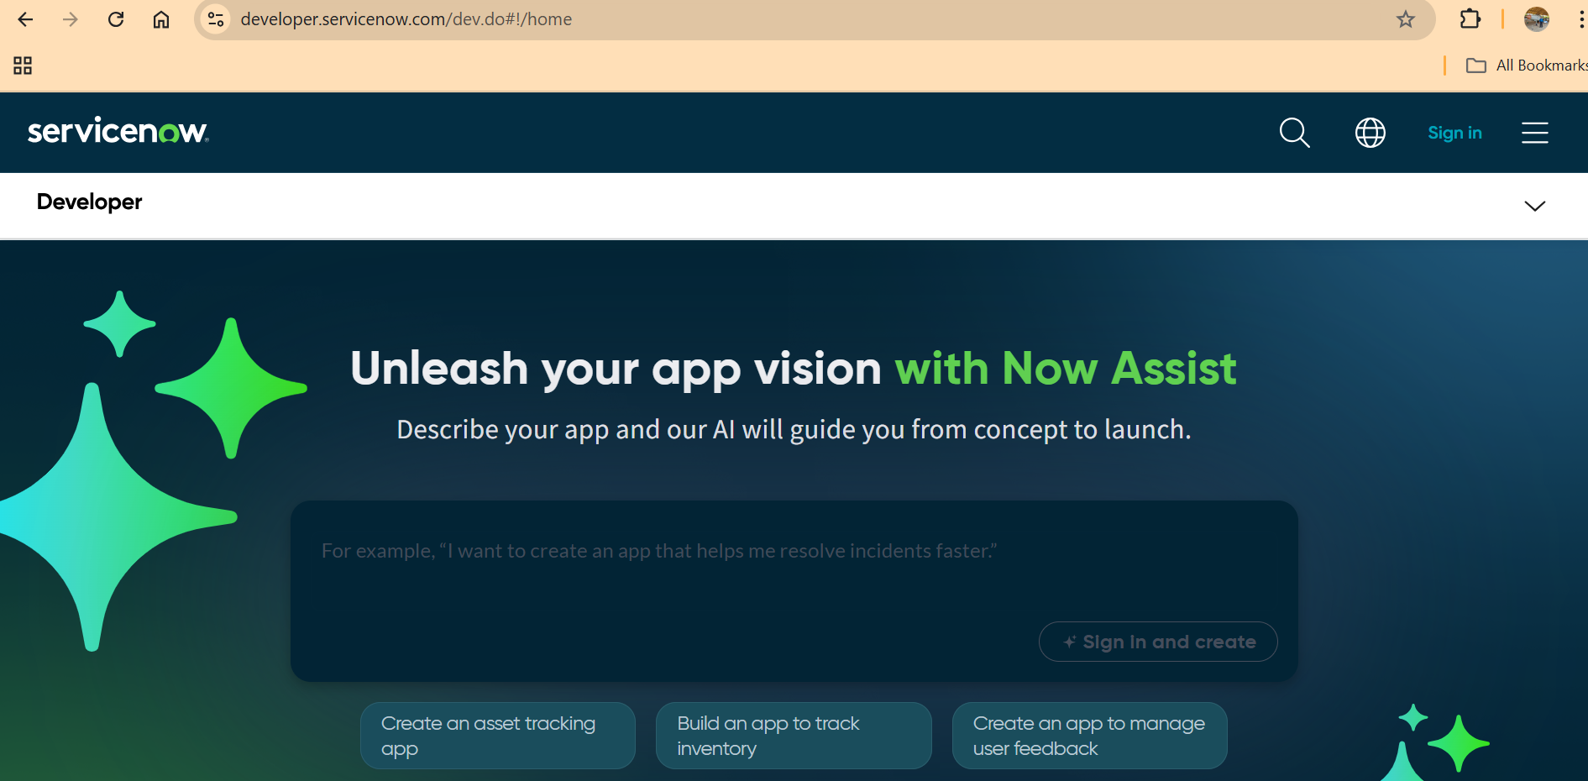

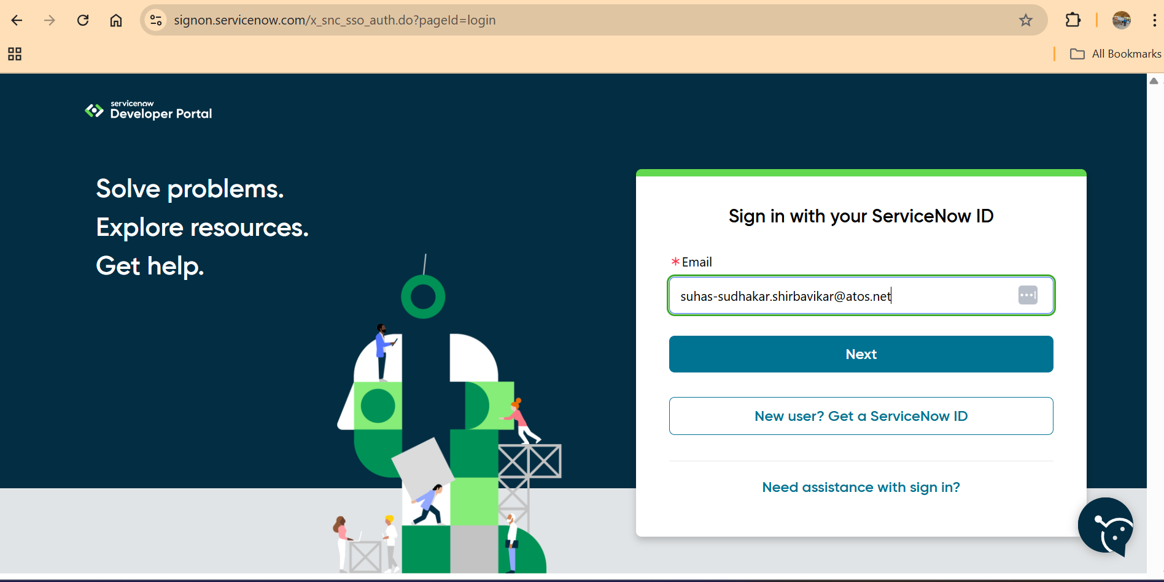
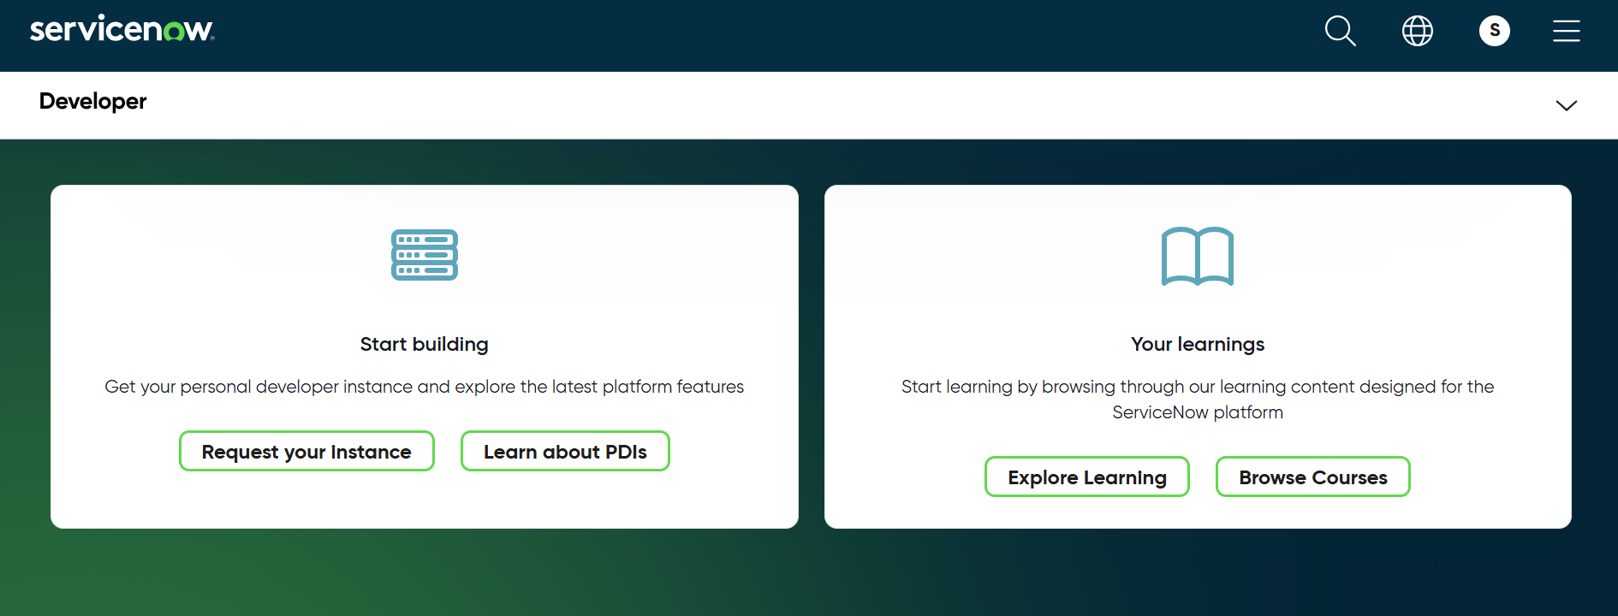
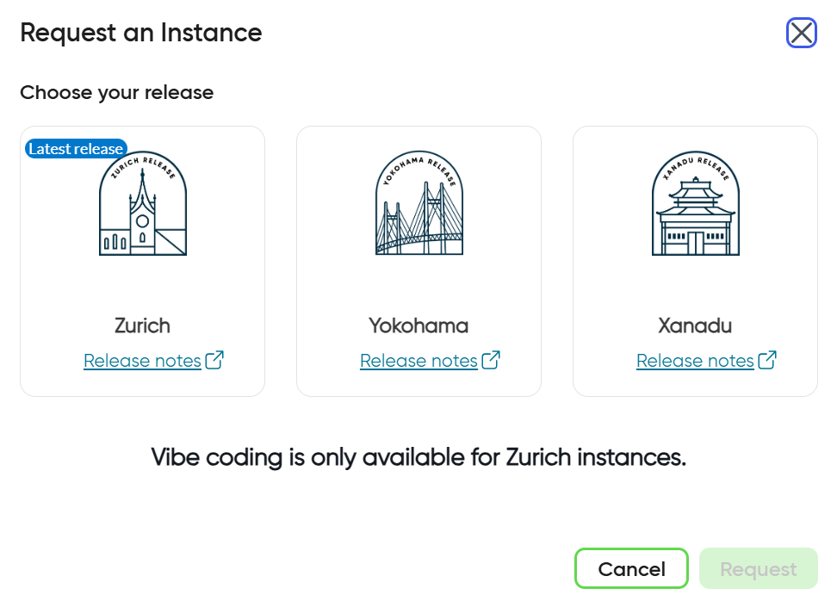
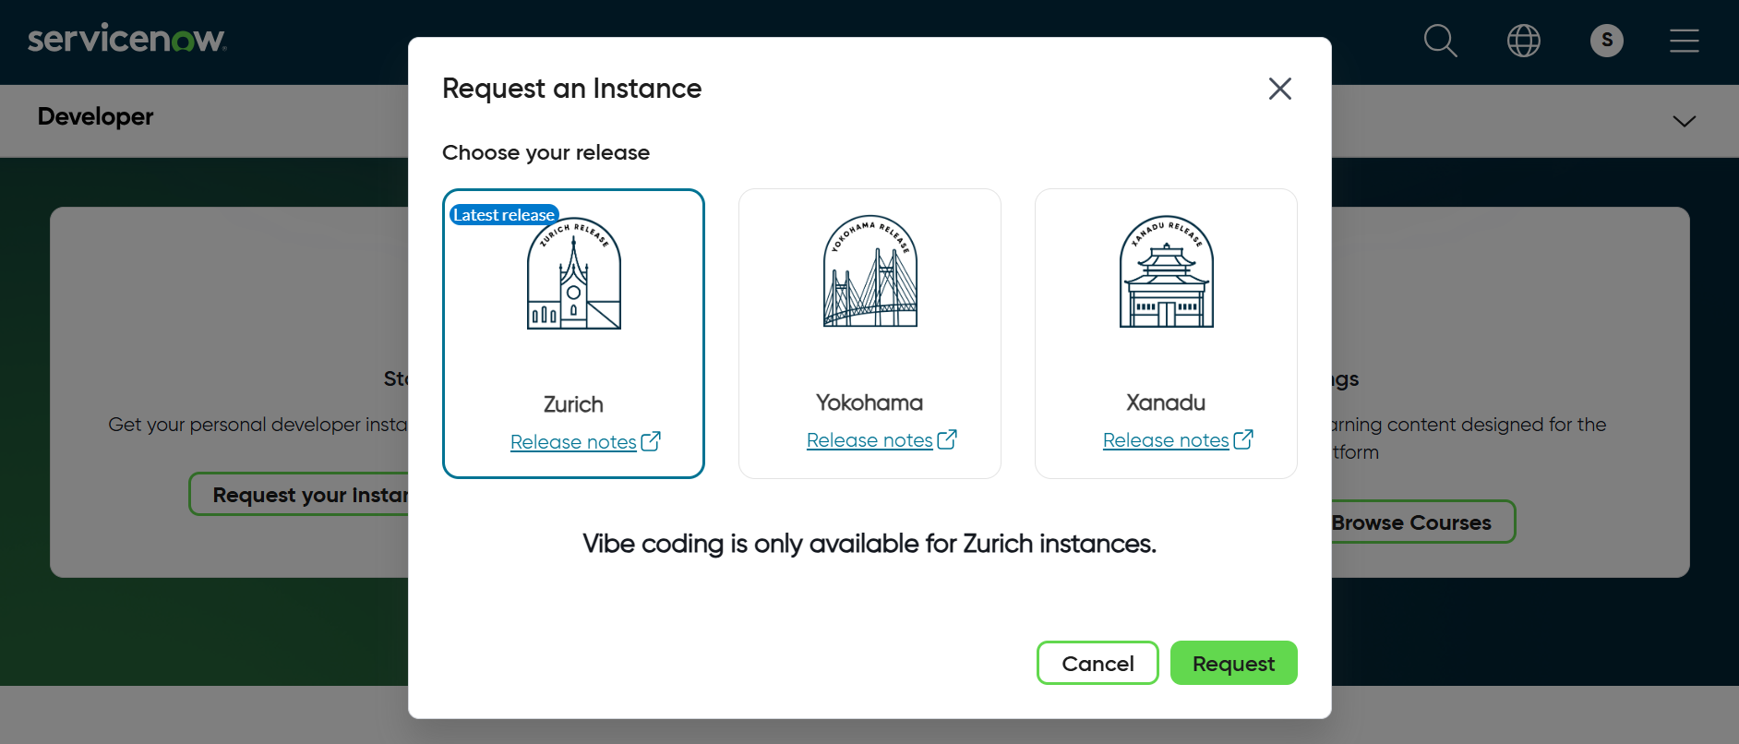
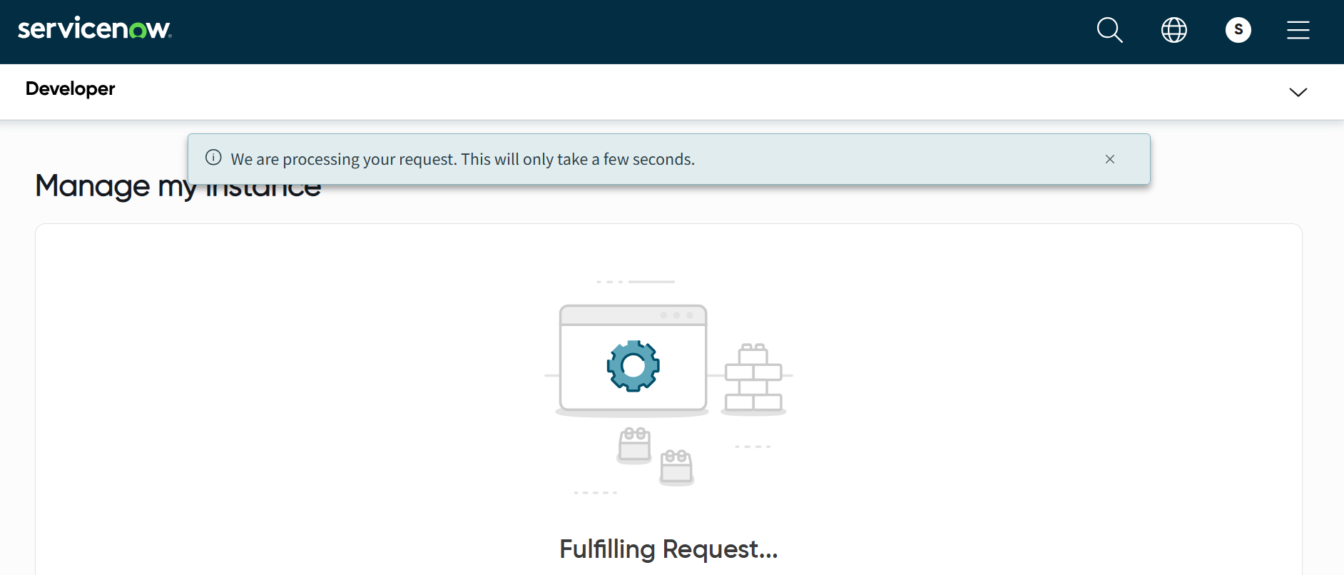

Some time may take 10 mins …
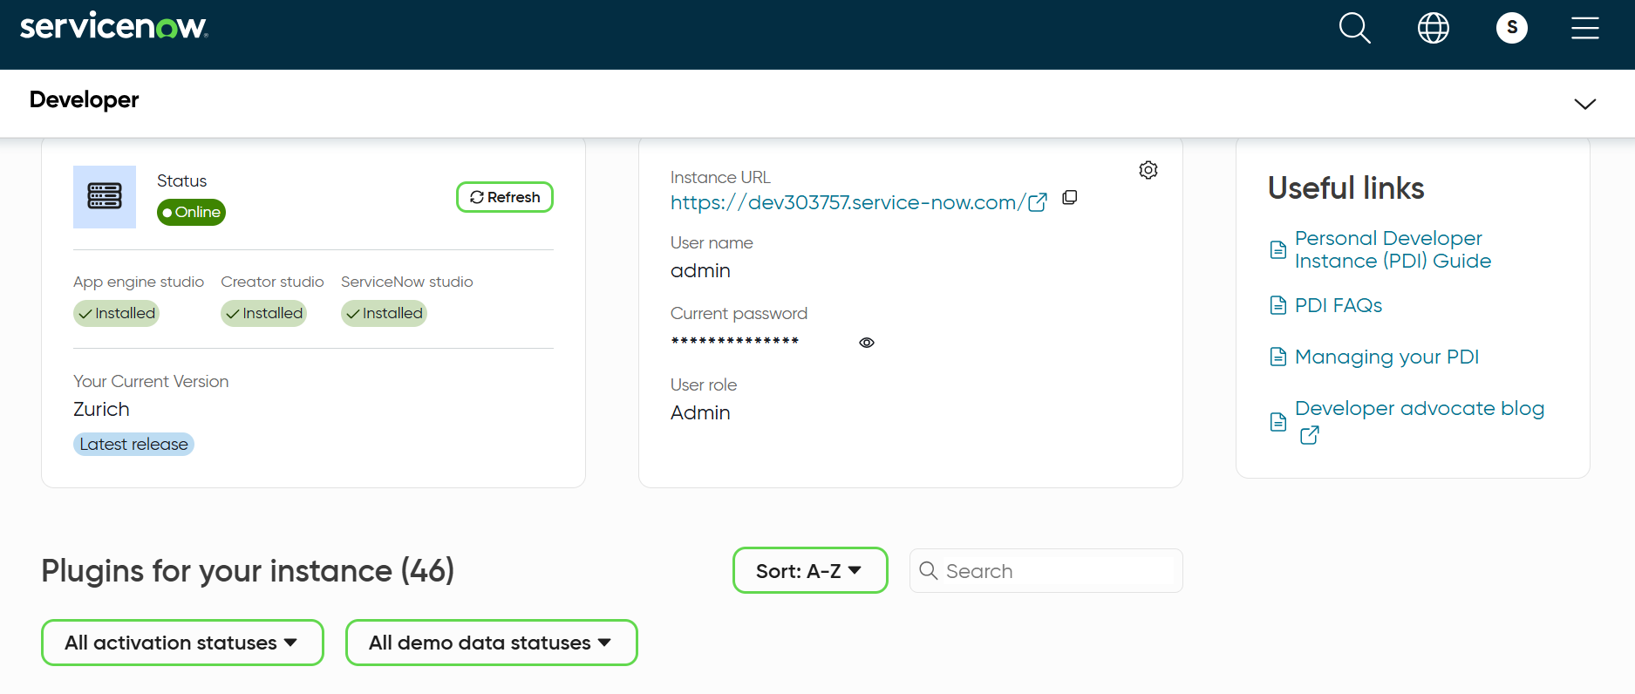

https://dev303757.service-now.com/login.do?user_name=admin&sys_action=sysverb_login&user_password=-o4gZ%40joU8IT
admin
password
after login to instant …

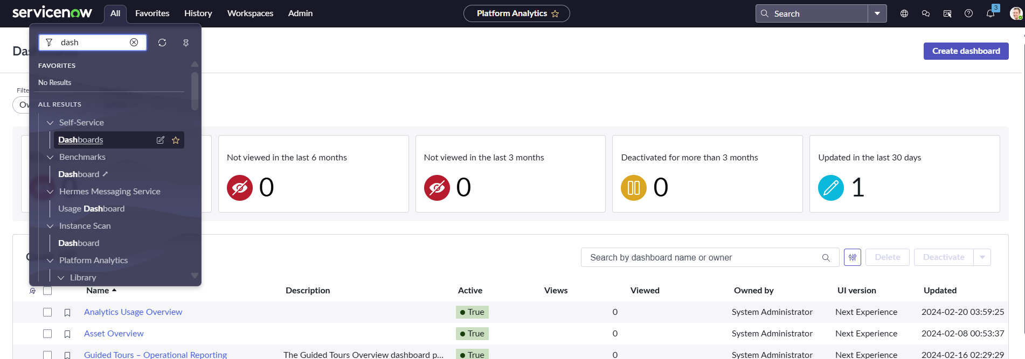
Click on Self Service
Dashboards
Click on Create dashboard …
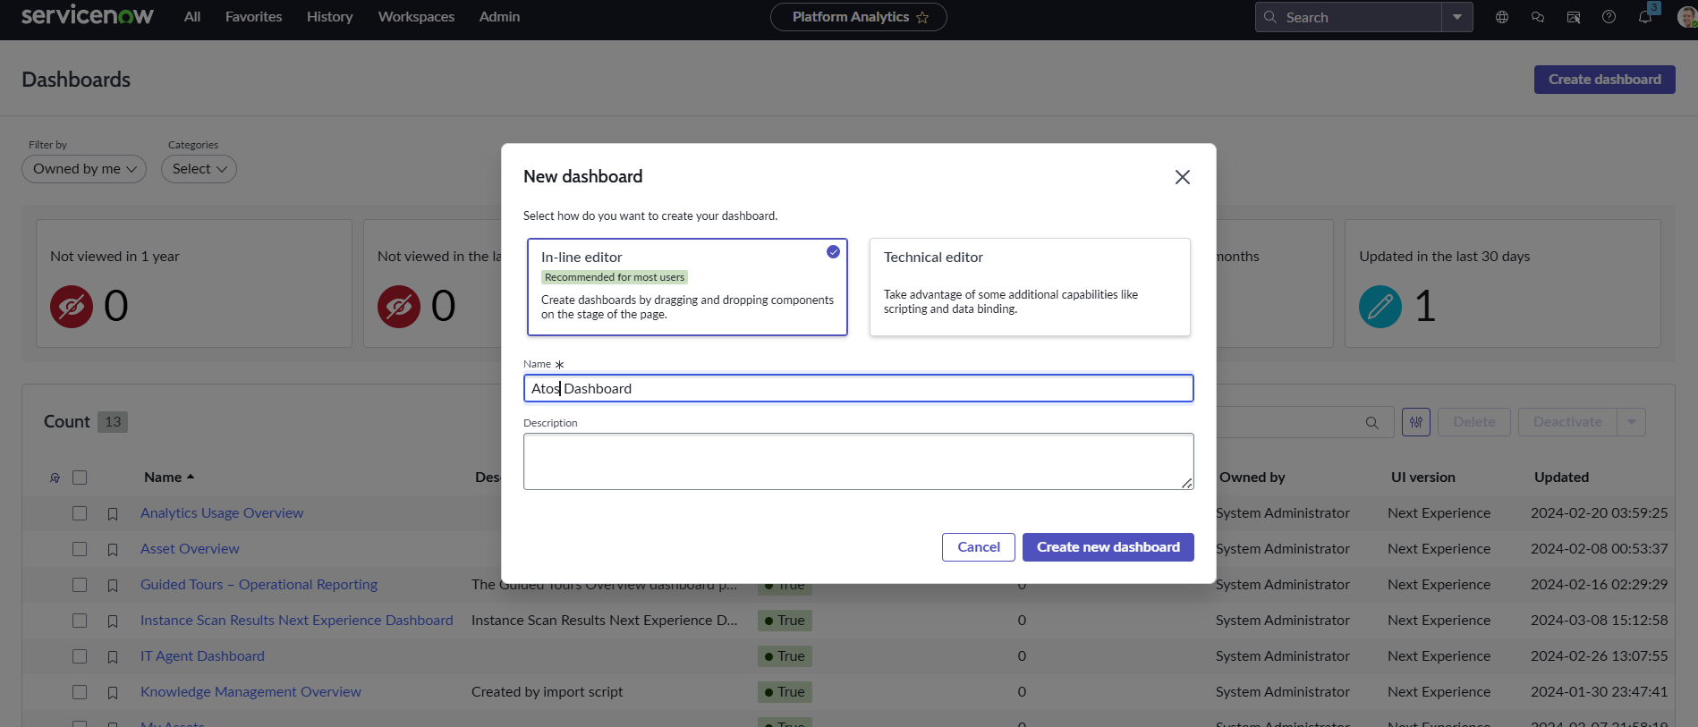

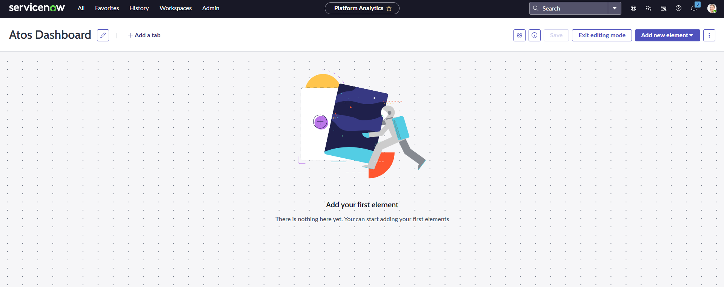

https://dev303757.service-now.com/now/platform-analytics-workspace/data-visualization-library

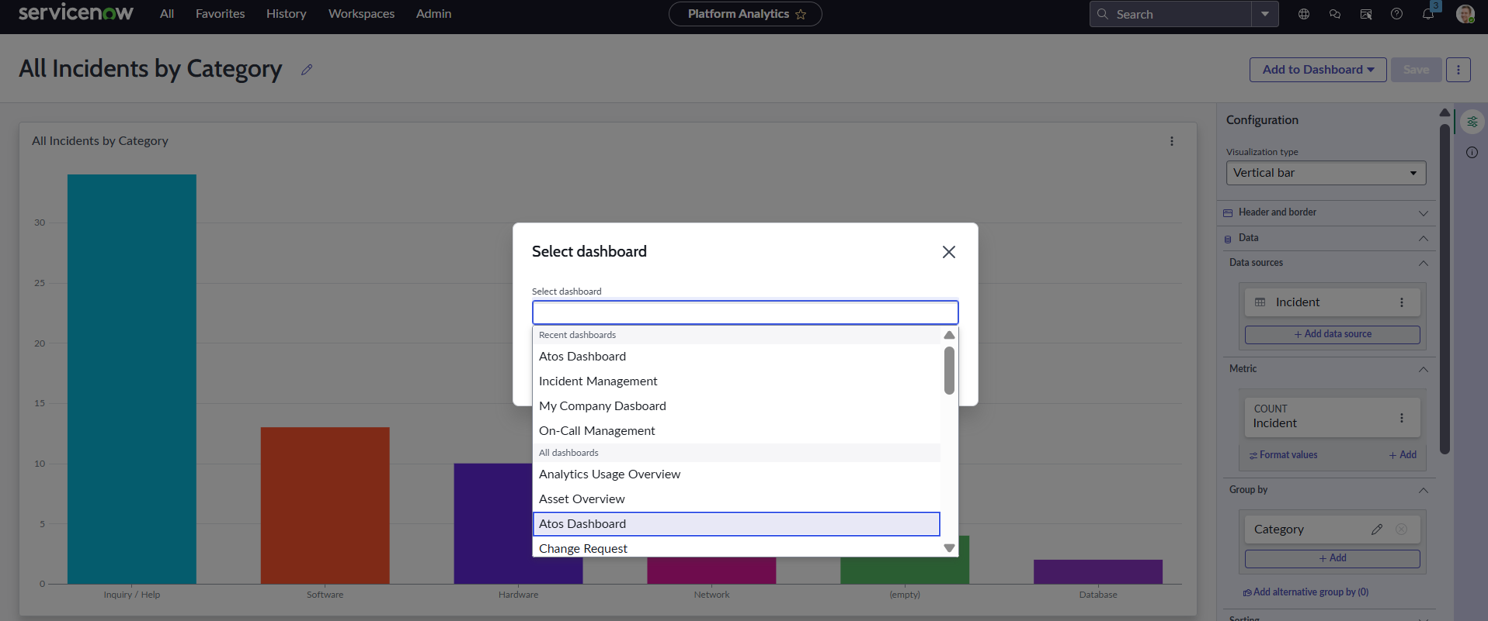
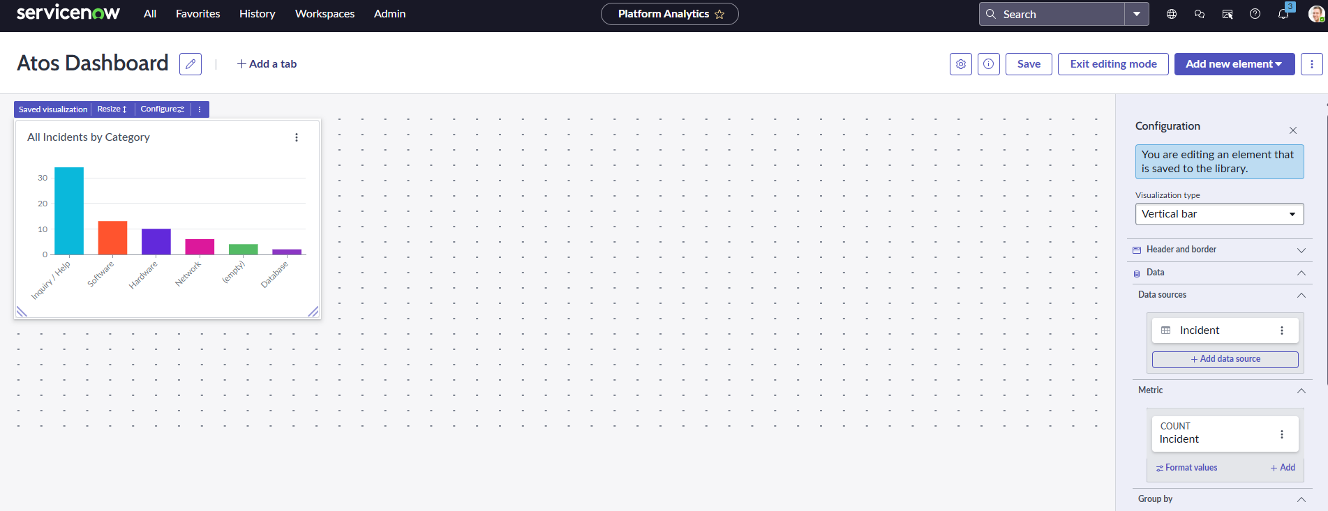

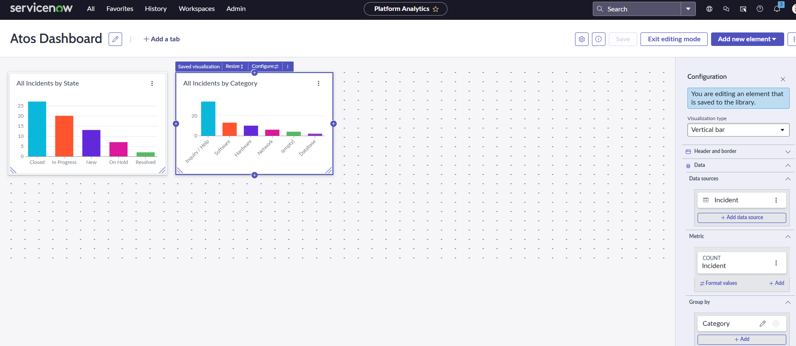
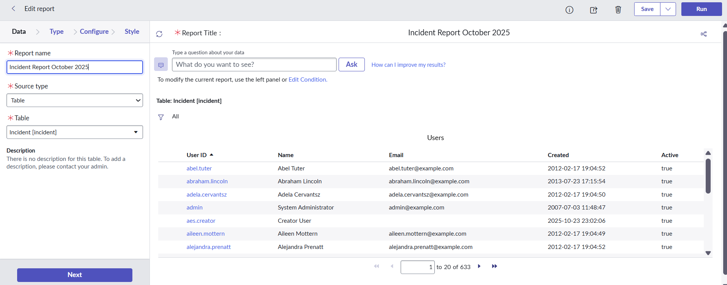
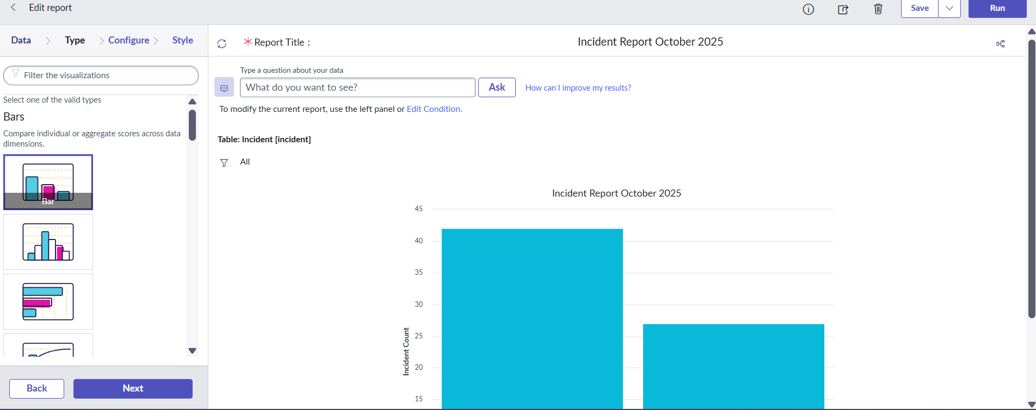

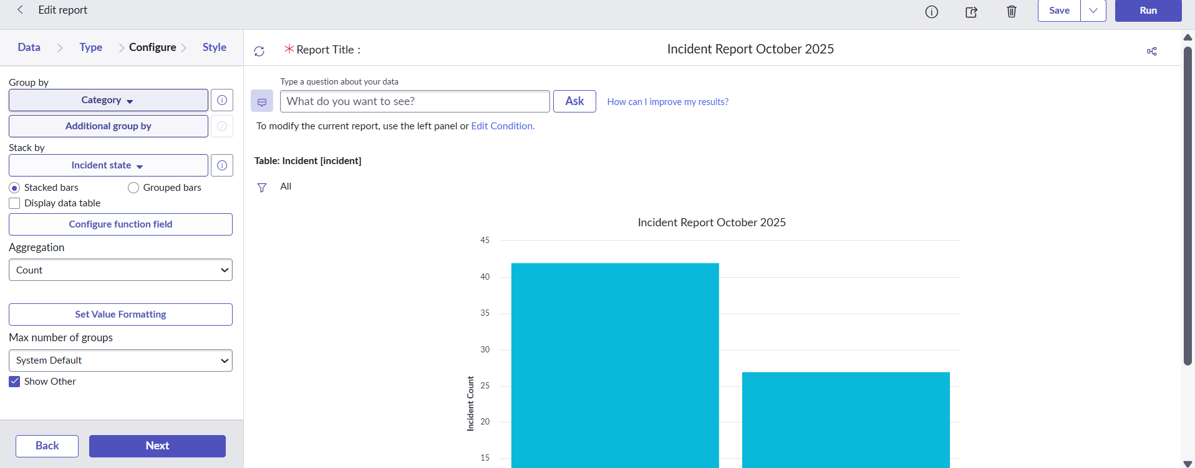

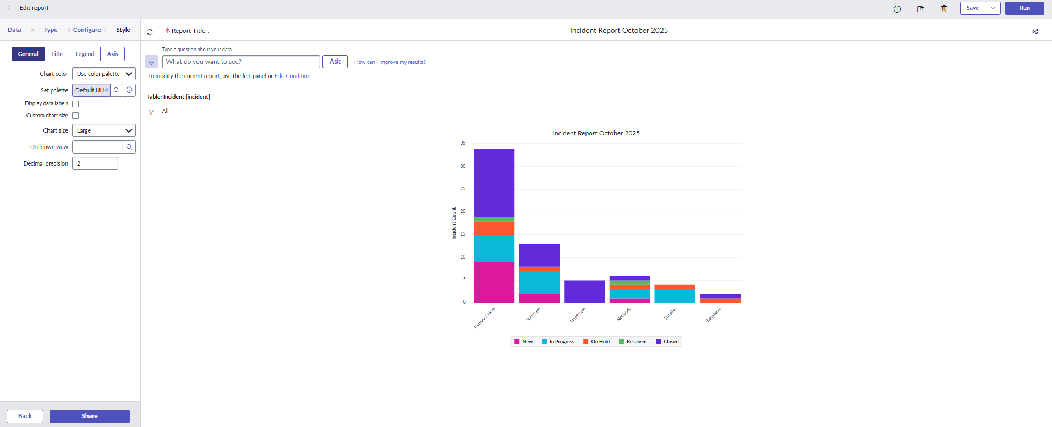

https://dev303757.service-now.com/now/platform-analytics-workspace/data-visualization-library
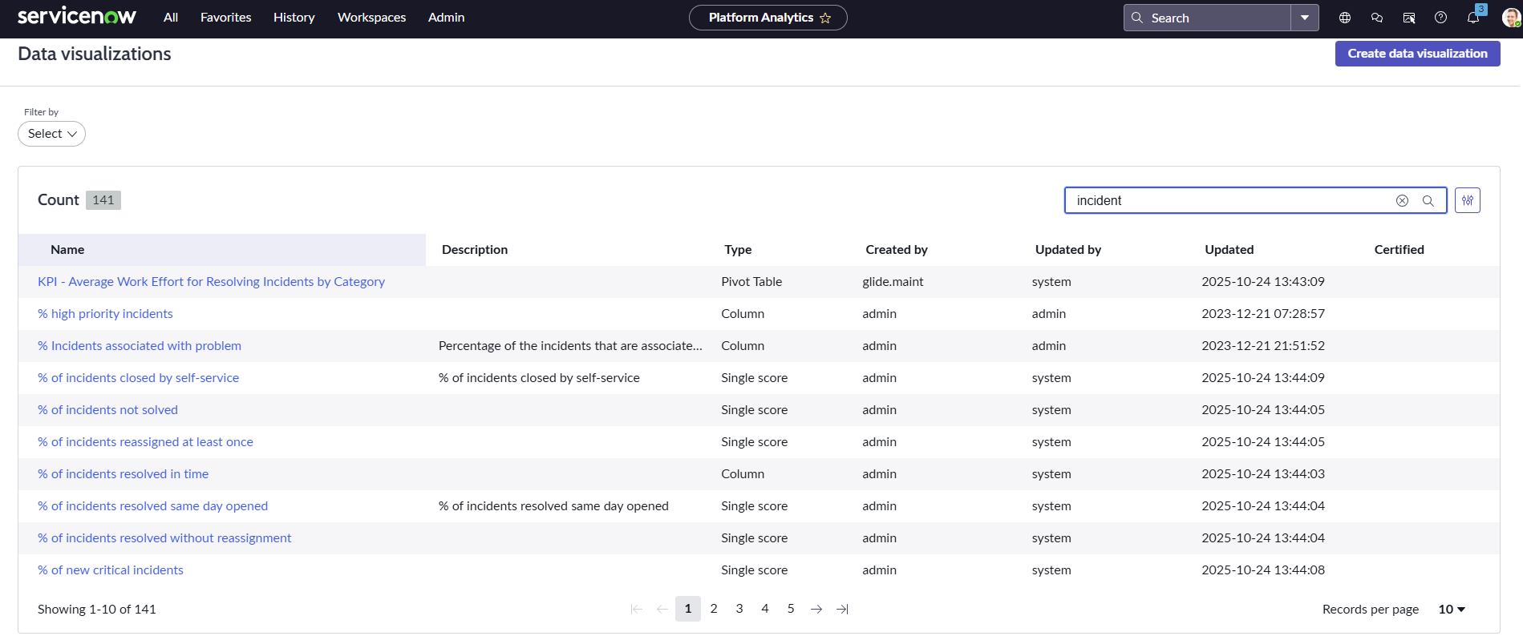
Based on Incident, we have 141 reports….
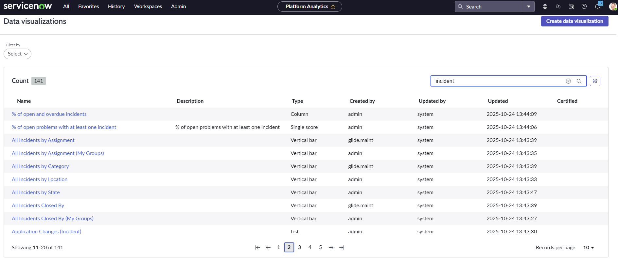
Click on All Incidents by Category …
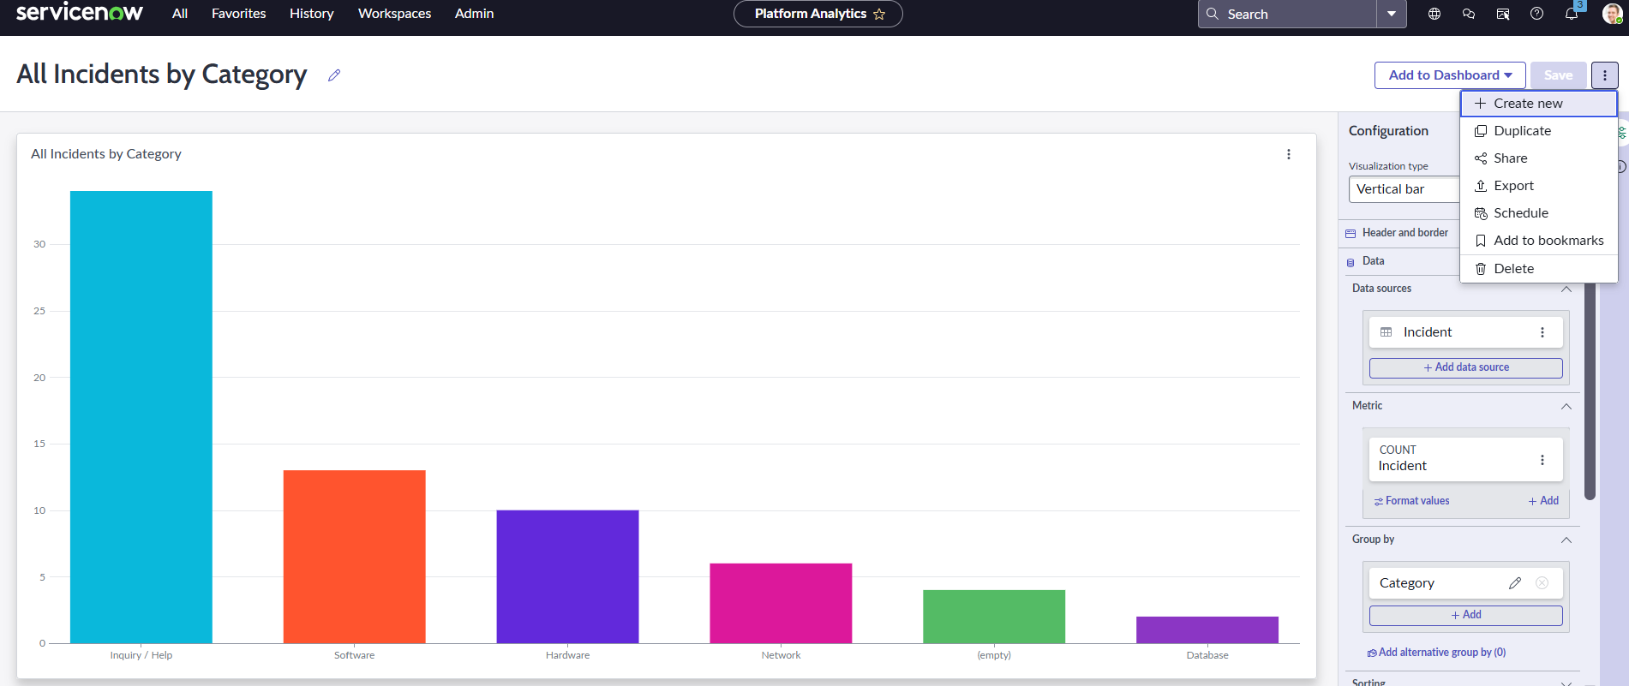
Click on Add to Dashboard..
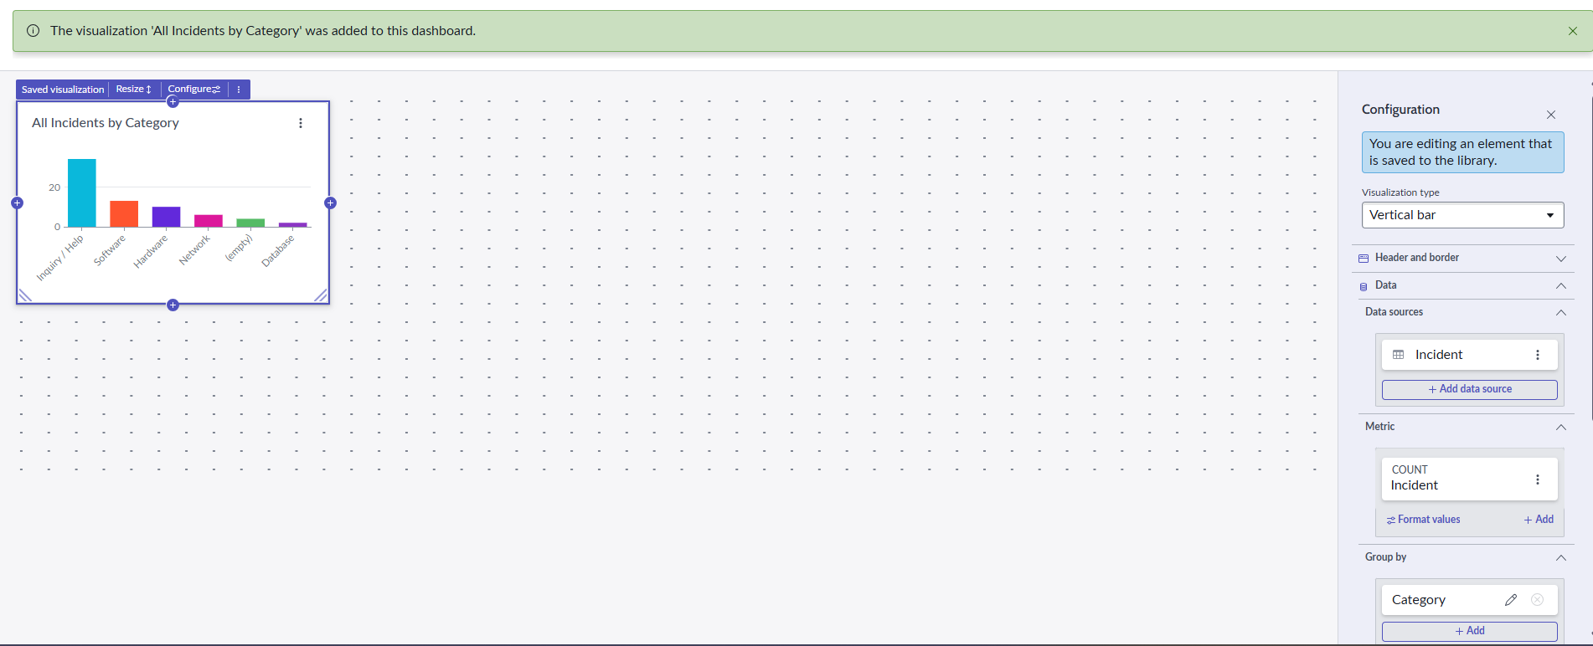
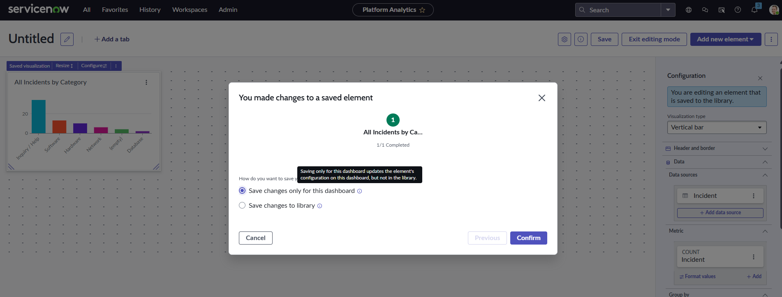

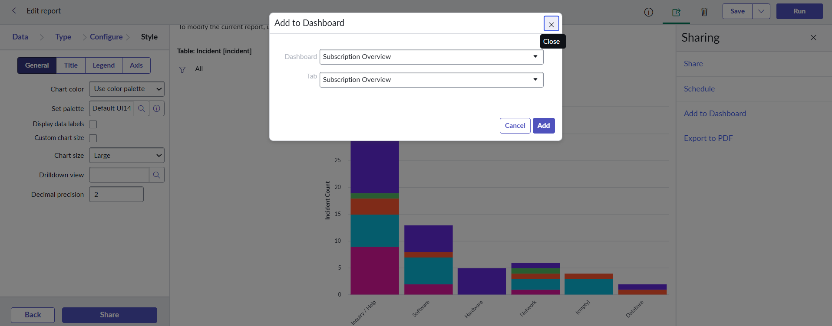
Add to Dashboard

After saving add to dashboard is enabled
